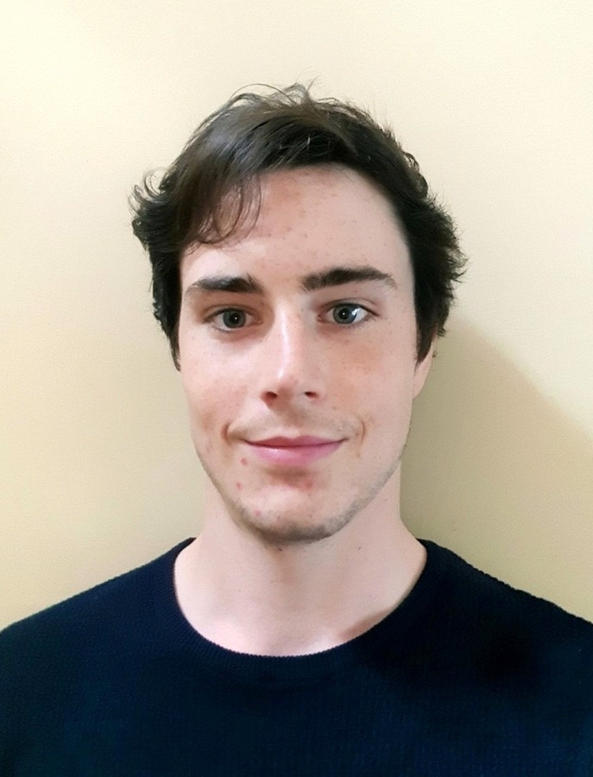**Kealan Jones**

+447495446864

kealan.jones@gmail.com

**Personal Profile:**

I am a recent graduate the University of Exeter, UK, having completed a four-year BSc Medical Sciences (with Placement Year) degree with First Class Honours. Currently, I am working as professional medical courier. I was born and raised in France and the French academic system, by Anglo-American parents, until choosing to come to the UK to pursue Higher education.

I am considered a hard-working, energetic and committed individual that can deal with heavy workload and pressure, calmly and efficiently. I am strongly task-focused in pursuit of set goals, enjoy problem solving and capable of taking initiative when the situation requires. Importantly, I aim to achieve positive results with a positive approach and am most motivated when I am working to help others.

**Education:**

* University of Exeter, UK (2015-2019) – BSc Medical Sciences with Placement Year (First Class, Honours)
* Lycée International Jean-Rostand, Chantilly, France (2012-15) – OIB (International Option Baccalauréat), Scientific Option, BAC S (Distinction)
* College de Bourgognes (2008-2012) – Brevet (High Distinction)

**Other qualifications:**

* IGCSE English Language (*A\**) and English Literature (*A\**)
* German B1 Language Certificate
* Licenced and responsible Driver

**Personal Achievements:**

* Exeter Award (2019) – *an employability achievement awarded to undergraduates of the University of Exeter demonstrating key professionalism skills.*
* Social Entrepreneurs of Enactus Finalist (2019) – *a national competition that involved several rounds of ‘pitch’ style public presentation of an entrepreneurial idea to a panel of corporate judges*
* Dean’s Fund Certification (2018) *– a fund awarded by the Dean of the University of Exeter Medical School to support select students in academic research projects and their presentation abroad.*
* Student Representative on the Lycee’s administrative board (2013-15) - *Representing the views of all the students whilst discussing budgets and the functioning of the school*
* Peer elected Class Representative for four years (2008-12) – *Liaison between students and teachers*
* Explorers Patrol Leader, *which has allowed me to assist in the organisation of international trips and projects, whilst collaborating with people from different cultures.*
* 650km charity cycle ride from Paris to Annecy and 300km cycle ride raising funds for Enactus’s BioSmart project.
* Hip-Hop Dance Regional Champions for 3 years running – *this required discipline and working cohesively within a team*
* Anglophone National Debating Competition Finalist – *this experience developed my presentation and speaking skills*

**Skills:**

* Team Leadership
  + *I have never shied away from the opportunity to direct a team, whether it be leading a team in running commercial projects for Enactus or captaining my university intramural football team*

*Skills: cont..*

* Fully bilingual/bicultural in English and French, with a competent level of German
* Presentation and public speaking:
  + *Small group learning and presentation are both key parts of my degree.*
  + *I have also had experience in public speaking, through participation in Start-up pitching competitions or giving workshops to Enactus members, and was chosen to help train and prepare a group of younger students for a Rotary Public Speaking Competition.*
* Time Management – *familiar with working to strict deadlines*
* Scientific Writing and Research – *co-author on two scientific papers in the process of being published*
* Competent in Online programming languages (html, CSS, JavaScript)
* Proficient in Excel, Word and advanced knowledge of PowerPoint; competent with Stata statistical package
* Advanced knowledge and proficiency with computers
* Key laboratory skills, including gel electrophoresis, aseptic technique, PCR, microscopy (upright and confocal) and cell culture, acquired during final year dissertation research project and practical sessions

**Work Experience:**

* *Sep 2019 – now –* Professional Medical Courier for IVF Couriers, transporting and coordinating medical specimen shipments between clinics internationally.
* *April 2018 - August 2019* - Head of Finance and Commercial for Enactus Exeter.
  + Enactus is an International social enterprise society with a chapter at the University of Exeter. It was created to implement projects designed to tackle important social issues such as homelessness, fuel poverty, and sustainability. My role involved managing the chapter’s finances and leading a team to raising money to finance the social projects, through fundraising initiatives and commercial projects.
  + Co-founded and led a local business, *Capture Exeter.*
  + Took the society from an annual revenue of £1500 to £10000
* *July 2019 –* Head cashier and treasury liaison in the Debenture Centre-Court Brasserie at the Wimbledon Tennis Championships, (high-end catering & administration).
* *September 2017 - July 2018 -* Researche*r* in the “Eye's Mind” cognitive science research team at the University of Exeter Medical School, exploring the neural correlates of imagination and visual imagery, specifically the cognitive basis of Aphantasia.
* *July - September 2015&16* – HB Leisure, as Stock Manager, Sales and Event Management ( Parc Asterix theme park, France).
* *Nov-Dec 2015* –Truffaut, (a large trans-national, French Garden products retail chain) working on contract, creating an interactive presentation designed to train future employees.
* *Dec 2012* –Beijing West Industries, writing a “Public-Interest” report on the functioning of the Magnetorheological suspension system and learning about the structure and methodologies of product development. (Work experience.)

**Hobbies and Interests:**

* Music (guitar, piano and musical composition)
* Cycling, Urban dance, Football, Squash, Skiing
* Social enterprise, Artificial Intelligence in Medicine